**Designing a Control System**

By now, you have encountered several control systems in BME 354 Lab such as the baby incubator. The baby incubator that you designed in LabView was a relatively simple control system, but it has all of the essential features of a control system: an output (Temperature) of a system that is used in a feedback loop to control the input (Power delivered to the heater).

NOTE: There are other systems that you may not realize are described by control theory. For example, op-amp circuits that you have used in lab utilize negative feedback to achieve their useful properties (How do you think they give extremely constant gain across a range of frequencies?). In fact, modeling the op amp as the control system (shown below) is essential to designing what goes on inside the op amp (at the transistor level).

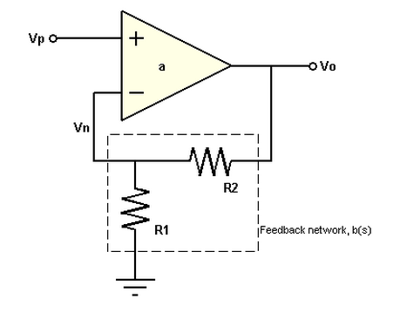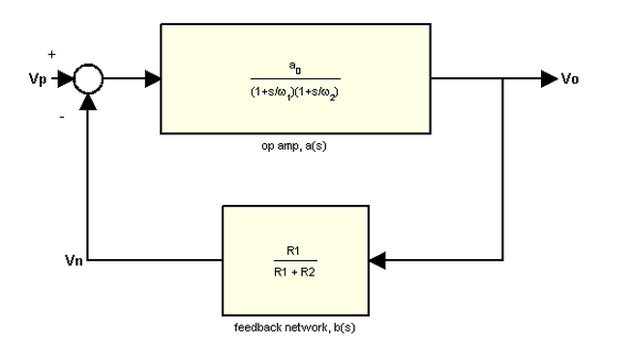

The interesting is that your discussion of oscillating systems (underdamped, overdamped, critically damped, etc) is widely applicable. Many physical systems can be modeled by these simple descriptions (op amps included). If these discussions escaped you during lecture, try to review them before digging into the project.

The part of control theory which you need to investigate for this project is *control* *algorithms*. The control algorithm in this case, is how you should design a system of regulated feedback to the reflow oven that considers the temperature of the system at any point in time. Here are a few questions to ask yourself as you consider the algorithm you will use:

1. Define the relevant resolutions. What are the units of temperature that are important to you? Can your electronics reliably measure ΔT ~ 1°C? What about .1°C? This is essential to determining how you should design the control system. More importantly, what is the minimum resolution of temperature that you care about for your application? Does a reflow oven need 1°C precision?
2. What are the relevant time scales in this problem? How quickly will your input / output change? What does this tell you about how fast you need to sample the output (temperature)? This part of the design process is akin to deciding how fast you need to sample a biosignal. Just like a biosignal(Which you have seen is not very well bandlimited), the time scales / relevant frequencies in this system may not be clear cut.
   1. What phenomena would affect this time scale? This is a good time to note that diffusive heat transport has **tD ~ L2.** If you have taken / are taking BME 207 (New #?) then you recognize this as a time scale for chemical diffusion.
   2. What would convective transport (i.e. using a fan in the reflow oven) do to the time scales that you have to worry about?
   3. For the scale of the reflow oven, this means that temperature still fluctuates on a relatively slow time scale (s to 10’s of seconds).
3. Is a constant sampling rate the best way to handle your measurements? Could you use a higher precision technique during periods of change? Think about how oversampling / averaging could help improve accuracy.

The considerations above will help you determine the design parameters of your feedback system, such as the sampling rate. The next thing you have to consider is what to do with the data that you collect from your system. Control systems process the outputs and control and input based on the output state. The most basic algorithm for controlling this feedback loop would be a binary thresholding algorithm such as the one implemented in the baby incubator lab. This algorithm is based on a simple decision:

IF Temp > Set Point –> Heater OFF

IF Temp < Set Point 🡪 Heater ON

This algorithm is simple, and quite effective for many systems, but we can do better. If you remember from your lab exercises, this algorithm has one principal failing, which is the oscillations that occur in steady state operation. The baby incubator temperature oscillated around the set point with a particular frequency. The other disappointing feature of this control system’s performance was the overshoot. When the temperature was ramped up to the setpoint, the heater pushed it way over the set point temperature since it kept pumping the same amount of heat until it had exceeded the set point temperature.

What if your control system could adapt to the overshoots and narrow in on the set point? What information do you need to collect to make your algorithm better?

The basic binary algorithm used in the baby incubator is unable to do this because it does not have memory. The decision to turn the heater on and off is made instantaneously by comparing the set point and the current temperature. In control system terms, this means that the system is memoryless.

HINT#1: Giving your system memory can potentially improve its performance.

HINT#2: Memory does not mean storing every past temperature. Be intelligent as to how you can record the history of the temperature measurements.

HINT #3: What is the most relevant quantity for your decision making process. Is it current temperature? Is it the state of the temperature (Too Low / Too High?)? Could you characterize how much it deviates from the set point temperature—what does this tell you?

**PID tutorials:**

PID Controller Intro:

http://www.youtube.com/watch?v=UR0hOmjaHp0

PID Control Examples:

http://www.youtube.com/watch?v=XfAt6hNV8XM